The Executive Summary
COVID-19 is an infectious disease that formerly was known as '2019 novel coronavirus'. COVID-19 was first detected in China's major cities and provinces. The spread of the infection was also reported in other countries, including Saudi Arabia. The confirmed cases across the globe are alarming, that is over 5.1 million as Saudi Arabia reports over 70,000 cases. The objectives of the research are to determine the impacts of the Covid-19 crisis in Saudi Arabia and assess whether the country will survive the pandemic crisis. The Methodology that will be utilized in this project is descriptive analysis. Descriptive statistics of Saudi Arabia will be utilized in describing the concepts and data included in the research. This pandemic has caused devastative impacts in Saudi Arabia. The pandemic has adversely affected the oil prices to drop due to the decrease in crude demand. With the lowering of the prices, the recession causes a decline in the revenues. Due to the coronavirus, the tourism industry could be hit up to 45percent in 2020. The impact of Covid-19 ranges from 35-45 percent decline in comparison to last year with the reliance on how the country reopens. The hotel industry has been impacted by the low occupancy ratio. Through the research, we shall be able to determine to delineate the possible measure and recommendations in mitigating the adverse impacts that are caused by this pandemic issue. Saudi Arabia is able to survive the Covid-19 pandemic crisis as the countries' expenditure will be cut and there will be a delay in the Kingdom's vision 2030 economic diversification strategy. Besides, the country has oil reserves; this shows that when the economy begins to open, it will be the first beneficiary in supply its natural oil resources.

Introduction
COVID-19 is an infectious disease associated with the same family as Severe Acute Respiratory Syndrome (SARS). Formerly the disease was known as '2019 novel coronavirus'. COVID-19 was first detected in China's major cities and provinces. The spread of the infections was also reported in other countries, including Thailand, Hong Kong, the United States, Macau, South Korea, and Taiwan. The common symptoms of Covid-19 are but not limited to, breath shortness, cough, and fever. The infections result in pneumonia or breathing difficulties in severe cases. The symptoms of the diseases are correlated to the influenza virus; thus, it requires more testing to confirm the patient's status, whether he or she is Covid-19 positive. The confirmed cases across the globe are alarming, that is over 5.1 million as Saudi Arabia reports over 70,000 cases. This pandemic has caused devastative impacts in Saudi Arabia. The pandemic has adversely affected the oil prices to drop due to the decrease in crude demand. With the lowering of the prices, the recession causes a decline in the revenues. Due to the coronavirus, the tourism industry could be hit up to 45percent in 2020. The impact of Covid-19 ranges from 35-45 percent decline compared to last year with the reliance on how the country reopens. A low occupancy ratio has impacted the hotel industry.

Objective of the Research Project
- To determine the impacts of Covid-19 crisis in Saudi Arabia
- To assess whether the country will survive the pandemic crisis

Importance of the research project
This assists in the determination of the strategies that are employed by Saudi Arabia nation and the efficacy of the implemented measures. In this research, we shall be able to determine.

The existing knowledge gaps and misconceptions and determine the possible measures and recommendations in mitigating the adverse impacts of this pandemic issue. The research study will provide descriptive data that will be significant for the associated authority and the planning agencies in implementing or deploying measures that are geared toward mitigating the Covid-19 infections and its impacts upon the economy of Saudi Arabia. The research study will create awareness of adopting healthy lifestyles that are made into managing and preventing complications.

Research Project Methodology and Hypotheses
The methodology that will be utilized in this project is descriptive analysis. Descriptive statistics of Saudi Arabia will be utilized in describing the concepts and data included in the research. There will also be a simple graphic analysis to form quantitative data analysis.
The hypotheses are that Saudi Arabia is prepared to address the crisis and will survive in this pandemic crisis.

Literature Review
Viral Etiology
As the year 2019 ends, identification of novel coronavirus was determined to a cluster of pneumonia incidences among residents in Wuhan, in China. The scientist in China associated pneumonia to unknown coronavirus strain, which was designated as 2019-nCOV. The initial symptoms were reported on December 10th, and the other 24 cases were also discovered, which were linked to the seafood market. In January 2020, the first death case of Covid -19 was reported as 41 other cases were clinically confirmed. At the end of January, the Covid-19 spread to the major cities as well as the provinces in China. 571 cases and 17 deaths were reported in China.
The infection rapidly spread in China, resulting in an epidemic, and this was charted by an increasing number of diseases across the world. Confirmed cases in countries such as Thailand, Hong Kong, the United States, Macau, South Korea, and Taiwan were also reported. In January 2020, there were 2 confirmed cases in Italy and the number increased to 90,000 confirmed cases by end of March. The outbreak of Covid-19 in Spain has been alarming since most of the population is aged above 60 years. At the end of March, 2020, the reported deaths were 4,089 cases where 96 percent were elderly individual aged above 60 years.

Mode of Transmission
The primary mode of transmission of Covid-19 is individual to individual contact with respiratory droplets emanating from one of the infected individuals. Upon sneezing or coughing, the respiratory secretions infect the other individual when he or she makes direct contact. The transmission of the infection can also occur when an individual touches contaminated surfaces and then touches their face that is mouth, nose, and eyes. The virus is capable of surviving on surfaces for some hours, but the risk can be mitigated through the use of a disinfectant.
Individuals at high risk: People at any given age can acquire Covid-19 on a daily basis. Old aged and individuals having chronic medications, for instance, heart diseases, diabetes, among others, are at higher risk of developing severe signs and symptoms. Limited information is available on the Covid-19 prevalence among the children since few confirmed cases are linked to children. In some cases, the virus is fatal, especially the older adults who have pre-existing medical conditions.
This is portrayed in figure 1 below :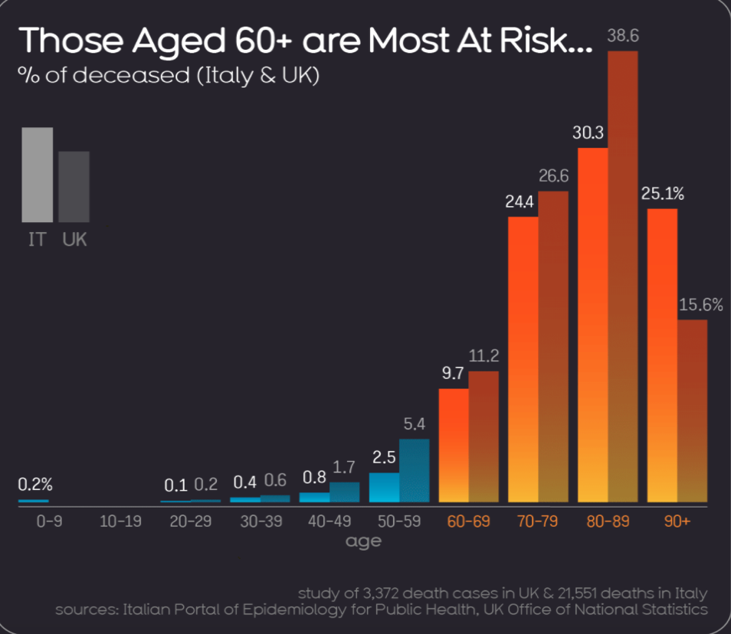
Clinical Manifestations: Pneumonia is perceived to be the most severe manifestation of the infection, characterized by breath shortness, coughing, and fever. The Covid-19 symptoms can be mirrored as influenza symptoms or the common cold.
Covid-19 Treatment: Currently, there is no available Covid-19 vaccine. Nonetheless, most of the symptoms related to Covid-19 can be treated as a healthcare provider can administer care to the victims making the infection less harmful. Numerous clinical trials have been conducted to assess the potential therapeutics effective for treating Covid-19.
Prevention of Covid-19
Similar to common cold, the public health methods are vital to reducing the spread of the diseases. The public health processes entail daily preventive strategies that includes but not limited to:
- The sick individuals should stay at home and isolate themselves from other members of the family
- When a person is sneezing or coughing, one is advised to cover their mouth and nose with flexed elbow or tissue usage. The tissues should be disposed of immediately after usage.
- Every person is expected to rinse their hands habitually with running water and detergent.
- The surfaces or objects which are touched regularly should be cleaned.
- Social distancing when in public, where the physical distance between two individuals should be at least 6 feet. This limits face-to face interaction with other individuals.
With the increase of investigative research and exploration of the disease, the public health professional will probably recommend other additional strategies or actions to be followed.
Similarities of Covid-19 and Influenza
The first similarity between Covid-19 and Influenza is that they both have analogous symptoms. Both of the diseases cause respiratory infections, which range from asymptomatic to severe infections and, ultimately, death. Secondly is the mode of transmission of the infections are the same. The virus is passed on through direct contact, respiratory droplets. In addition, similar public health strategies are adopted to prevent infections, such as hand hygiene and excellent respiratory etiquette. That is coughing or sneezing into the elbow or a tissue, and then the tissue should be disposed of immediately.

Differences between Covid-19 and Influenza Virus
There are significant differences between the two viruses. The primary difference is in the speed of the transmission. The incubation period of Influenza has a diminutive median (the period from infection to the symptoms appearance) and a shorter serial intervals (amount of time between the successive cases) as compared to the Covid-19 virus, which has serial intervals approximated between 5-6 days. The serial interval of Influenza is 3 days, which signifies that Influenza spreads faster as compared to Covid-19.
Besides, the possibly pre-symptomatic influenza transmission is the primary mode of transmission, whereas, in Covid-19, there are some individuals who can shed of 24-48 hours before the onset of the symptoms, though this does not appear to be the primary mode of transmission.
In the transmission of Influenza, the most vital driver is the children. On the other hand, children are less affected by Covid-19 as compared to adults. The rates of clinical attacks are low for the 0-19 age group. Those who are at risk for Covid-19 are the older adults and those with prevailing conditions, whereas children are the most risk population for influenza infection. Other affected populations include pregnant women, the elderly, and the people with immunosuppressed.
There is a higher mortality rate for Covid-19 as compared to Influenza cases. Even though the rate of mortality for Covid-19 is yet to be fully known, the crude mortality rate is 3-4 percent, whereas, for seasonal Influenza, the rate is below 0.1 percent. It is important to note that the mortality rate is usually determined by the accessibility to quality health services and other significant factors.

Body of the Report
Responses to Covid-19 outbreak
In January 2020, the number of cases of Covid-19 increased across the cities and provinces in China. In accordance with Professor Li Lanjuan, the National Health Commission convened professional experts to assess the ramifications of her proposal that the last resolution in containing the epidemic was implementing a lockdown on Wuhan. The authorities issued a notice to halt down all the normal traveling routes and activities within Wuhan. It is reported that approximately 300,000 Wuhan residence fled by train to other cities prior to the lockdown. Finally, on 23rd January 2020, China's central government-imposed Wuhan lockdown and other neighboring cities as a protective measure to quarantine the epicenter of Covid-19. This move which was acknowledged by the World Health organization was termed as "unprecedented in public health industry"
The figure bellows shows the timeline for Covid-19 from 2019 to 2020.
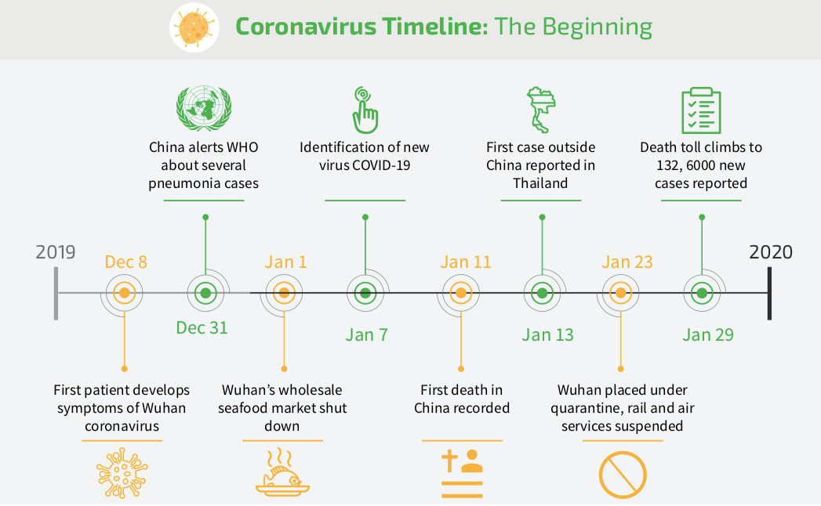
Global Response to the Pandemic
Countries are swiftly implementing measures to slow down the transmission of Covid-19 through testing and treating the identified victims, deploying contact tracing, limiting travel arrangements, quarantining the individuals, closing restaurants, implementing ‘work at home’ strategies and cancellation of large gatherings, for instance sporting events. The communities are adopting non-pharmaceutical public interventions (NPIs) to assist in slowing the spread of the infections. Since this pandemic flu is new and there is no known vaccine and the human population have minimal or lacks immunity against it, then NPIs are the best strategy of controlling the pandemic virus, especially in the absence of the vaccines.
In accordance with the World Health Organization, infection chance can be reduced through:
- Washing hands using alcohol-based sanitizers, or washing the hands with running water and soap.
- Maintenance of minimal distance of one meter between two people
- Avoiding crowded environments
- If an individual has minor symptoms the individual should stay at home and self-isolate
- Every person should adhere to good respiratory hygiene.

Contact tracing is one of the old aged strategies utilized in controlling the spread of the disease. The technique has been successful in containing SARS, MERS, Ebola, and Tuberculosis, among others. This strategy commences with the people who have tested positive for the Coronavirus. The people who have close contact with the infected person are also identified. The contacts are usually supported during the quarantine period until they surpass the risk window or develop symptoms or proven not to be exposed. Extensive testing facilitates effective contact tracing optimally.

Figure 3 below shows how contact tracing works.
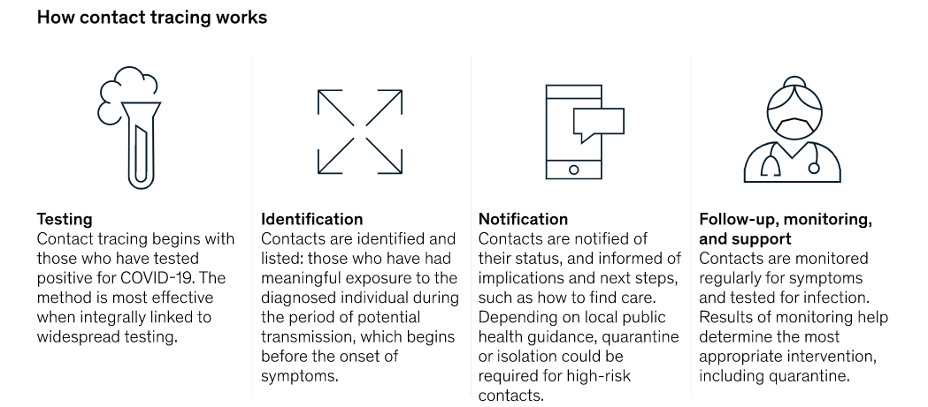

Economic Impact of Covid-19
The Covid-19 pandemic has led to an economic crisis that has posed massive challenges both globally and locally. The pandemic has immediately hit the services as well as manufacturers leading to massive laying off of personnel. The travel industry has not been left behind. It has suffered casualties as several airlines, and the hotel industry is at the verge of bankruptcy and collapsing as nations close borders, blocking the movement of publics in containment of the Covid-19 transmission. Other sectors such as tourism, hospitality, other logistics sector have also been affected. The high intensity, as well as NPIs durations, have the potential of lowering the cumulative mortality theoretically at the cost of the countries' economy.
The manufacturing and production industries based on China have been affected heavily. Those in the Asia-pacific region, as well as other regions, have been impacted adversely. Due to the pandemic, there has a surge in demand for health and web-based services, for instance, e-commerce, food deliveries, and online education.
Small and medium sized enterprises (SMEs) have been greatly affected considering their limited resources and accessibility to credit for their working capital. SMEs account for approximately 96 % of all business and 67% of the private-sector jobs in the Pacific and Asia. Implementation of viable strategies in reducing the labor market displacement as well as facilitation of labor adaptations could minimize the job losses. The decisions resulted in laying-off, bankruptcies, and disruptions in supply-chains, non-performing loans in the banking industry, increase precautionary savings, and postponed investment strategies causing an adverse demand shock.

Significance of China
China is the largest exporter and importer in the world, and this has greatly affected the countries which depend on China for intermediate inputs. For instance, Apple and Nike are a case example.
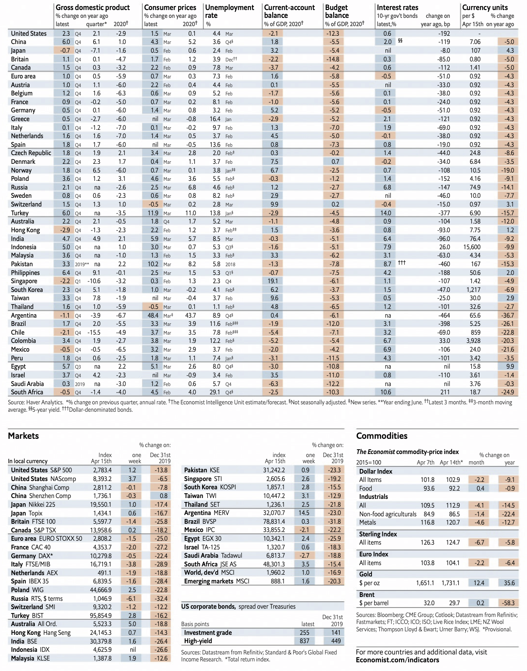

In the previous figure, there was a decrease in the GDP of China within the first quarter, and this is negative news to the whole world since Chin contributes approximately 16 percent to the global economy. Prior to the pandemic, the approximated GDP of the first quarter in China was 6 percent.
Relevant Business and Economic data
The economic health and business impacts felt across all countries. These include;
- In Europe, the car manufacturers that are Ferrari and Volkswagen have suspended their production.
- Tokyo Olympic Games were postponed to 2021
- Cruise operations have been cancelled
- There are low estimates of ad revenue for Amazon and Facebook
- Airbus has been suspended its production in Spain as well as France
- There is the closure of casino resorts in the US by MGM
- The borders are being reinstated in the EU regions,.
Management of Pandemic in Saudi Arabia
As the economy is shut down, the government in Saudi Arabia ensured the citizens met their needs. In accordance with Al-Jadaan, the Finance Minister in Saudi Arabia employed to adopt three resolutions in addressing the pandemic: Fiscal consolidation, removal of subsidies, and increased taxes and fees. The finance minister claimed that the country is facing a global crisis, even with the provided financial reserves and positions and the government debts, which is relatively low.

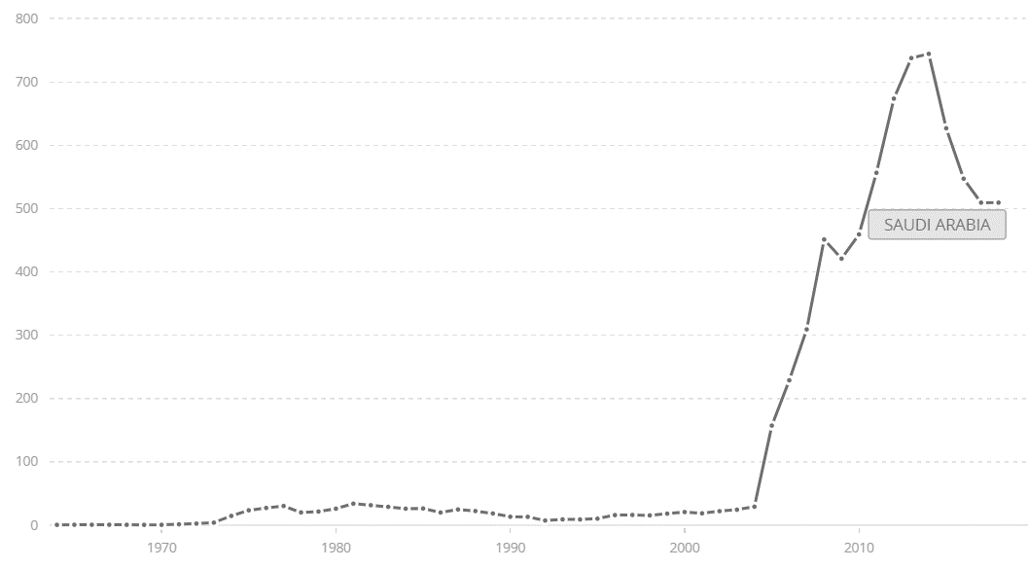
The figure shows the Total reserves in Saudi Arabia by $Billion
Al-Jadaan affirmed that the expenditure challenge is associated with an increase in health bill costs. The current expenditure is 80 percent more, and it is challenging to lower. The greatest challenge is the Fiscal sustainability for the short and medium-term, and the ultimate impacts rely on the crisis duration. One of the primary challenges facing the country is handling the economic crisis and implementing economic rationalization policies to reduce the expenditure and diversity of the income sources.

The impact on the Oil sector
The pandemic has adversely affected the oil prices to drop due to the decrease in crude demand. OPEC+ has a significant role in reducing the country's loss from the oil prices by making negotiations with the OPEC members. The prices have declined by over 60 percent.

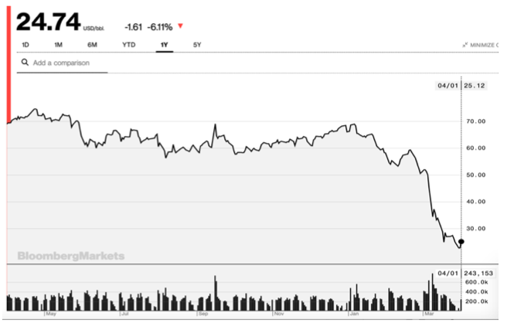
In the previous price level, there was a production boom in the United States. The decline in demand was due to Covid-19. When the OPEC+ decides to defend the price, the production should be reduced by 50% due to global demand shortfall. The US will continue expanding its supply resulting in marginal wars among the marginal producers. Given the Shale Oil production profile, the price will be bound by their marginal cost, and the production in the US will decline, leading to an increase of KSA market share. KSA initiated a price war with Russia, which resulted in 65 percent fall in oil price. This was triggered due to termination of dialogue between the OPEC and the Russian government over recommended oil-production cuts. Russia breached the agreement which resulted to a fall of OPEC+ alliance.

The nation had fiscal break-even price of oil approximated at US$ 83. With the lowering of the prices, the recession causes a decline in the revenues; thus, Covid-19 will necessitate additional spending.
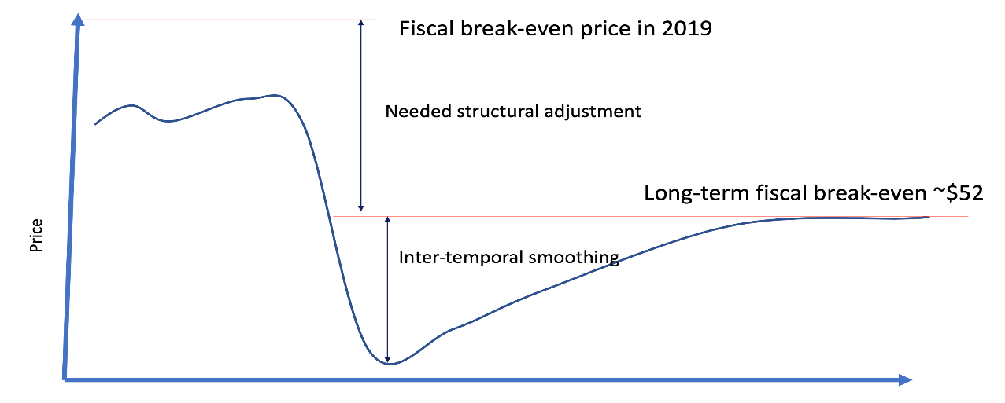
Measures to be implemented
- Cutting down the public wage bill
Since the large population of the KSA is employed by the government, the salaries of the public sectors are the largest chunk of the government expenditure. In order to cope up with the Covid-19 economic crisis, the government should cut down the public wages for instance cutting down the salaries by 40 percent. Even though slashing the salaries or firing of the employee would have unfavorable choices in the current pandemic, the citizens should the government top priority.
- Major investments that were planned should be halted
In order to sustain the strength and resilience of the countries during the Covid-19 pandemic, the countries should cut down the major investment that were proposed by a third as well as laying off of the personnel in order to mitigate the effects of the coronavirus outbreak and the fall in oil prices and demand.
- Devise other ways of raising the revenue such as standard taxations
The tax administrations are easing up the tax burden among the people through deferment of tax payments due in instalments or by making downward modifications to advance the payment of tax. The policy makers can raise the revenue of the countries through reduction of the tax breaks and expansion of the tax base.

Impact Pandemic on Tourism
Covid-19 has resulted in halting 50 million jobs across the globe, with Asia been the worst-hit region. After the outbreak is over, the tourism industry will take ten months to recover (World Economic Forum, 2020). Covid-19 has an adverse impact on the tourism industry with the potential of shrinking the travel sector up to 25 percent in 2020.

Covid-19 Impacts on Tourism Industry in Saudi Arabia
Due to the coronavirus, the tourism industry could be hit up to 45percent in 2020. As the country launched a new visa scheme for 49 nations, in 2019, the outbreak of Covid-19 caused the program to be closed in order to curb its spread. This resulted in borders closure for tourists from at least 25 countries. The impact of Covid-19 ranges from 35-45 percent decline in comparison to last year with the reliance on how the country reopens. The hotel industry has been impacted by will low occupancy ratio.
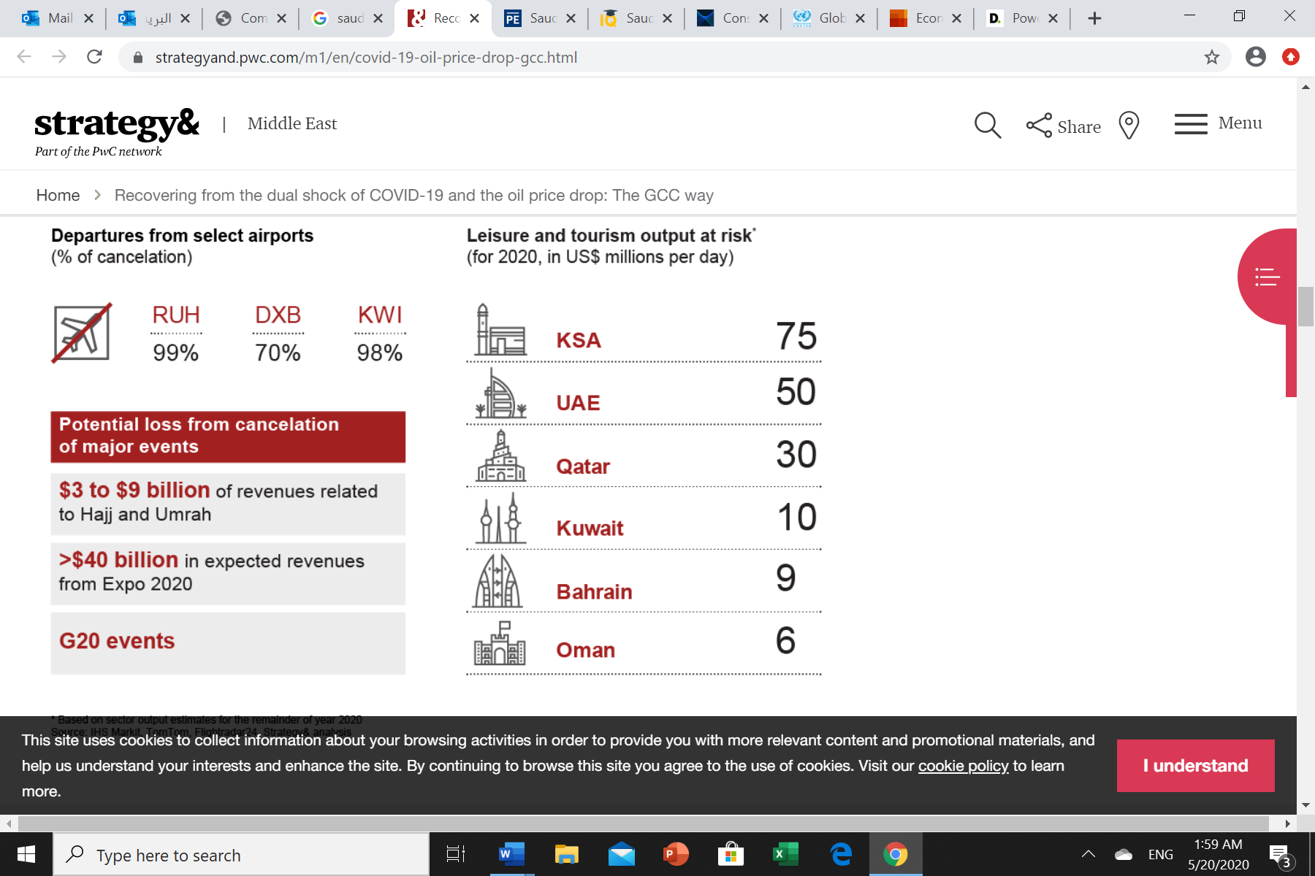

What will happen after reopening?
The tourism has been affected detrimentally considering that Tourism, as the international movements had been halted. In February 2020, KSA closed all its borders to foreign pilgrims and banned all the travels in and out of the country. Pilgrimage is core business in the country, where its hosts, Mecca and Medina, the two holiest Islam sites. The government is planning to reopen the economy when the pandemic is under control. This shows that all precautionary measures will be implemented.
Flights situation in Saudi Arabia and what will happen after reopening
The airlines had suffered fall out due to the pandemic with international as well as domestic airlines closed and laid off approximately 20 percent of its personnel after decimating the travel demands. On May 21, the Airlines for instance the Airlines have opened its scheduled flight domestic services. This lead to precautionary measure to be observed such as use of thermal camera to check the passengers, installation of sterilizing devices for the stairs, employing social distancing among others.
The new normal in Saudi Arabia after reopening and assumptions of it.

The country is implementing precautionary measures and even after the reopening the lock down to prevent the second phase of the Covid-19 pandemic. The impacts of the pandemic is widespread and long-lasting. Rapid and effective actions must be implemented by the government in keeping the employees at work and reopening of the firms and business in order to boost the economy. The assumption is that within a period of time the economy will buffer and all the precautionary measures and policies will be followed.

Tradeoff between Health and Economy. Is the cure worse than disease?
The country is adopting and implementing the NPIs to foster economic growth and development. The challenge is finding the balance among the three objectives that is effectively combating the covid-19 pandemic, provision of financial support to the displaced workers and restarting of the economy. The measures to be implemented are manageable and feasible thus the cure cannot be worse than the disease.

Conclusions
The primary objective is whether Saudi Arabia is able to survive the Covid-19 pandemic crisis. The nation has employed new strategies. The Minister of Finance claimed expenditure would be cut, and there will be a delay of the Kingdom's vision 2030 economic diversification strategy. Besides, the country is capable of borrowing with the objective of restoring the fiscal reserves. Despite the fact that there is a low-debt to GDP ratio of 24 percent, this indicates that there is the existence of contingency plans for the purpose of controlling and managing the crisis. Besides, the country has oil reserves; this shows that is the economy begins to open, it will be the first beneficiary to supply its natural oil resources.
Implications
With regard to the trade-off between public health and economy, "free lunch" does not exist in an open and connected economy. Even with the pandemic, some nations have adopted NPIs to strengthen their economic spill. NPIs are likely to minimize the local demand and the demand for goods and services. NPIs have a likelihood of disrupting the supply chains, and this contributes to a generalized supply shock in an open economy.
The information flow among the locals signifies that the non-policies limit economic participation as well as labor supply, even in countries without the NPIs.
Recommendations
The country should be geared into stimulating the economy. Since supply and demand in the labor market have been affected, measures taken should include the provision of support for the workers as well as the enterprise in all the sectors in order to prevent any additional contractions in investment as well as consumption. The fiscal and monetary strategies should be used in supporting employment and social protection. Timely and coordinated fiscal and monetary policy implementation could prevent individuals and companies from encountering bankruptcies and facilitating sustainable recovery. The country should invest in the health and social sectors in order to expand the treatment and limit the rate of deaths. Besides additional fiscal resources should be implemented to support the health systems in the nation.

https://www.frontiersin.org/articles/10.3389/fmed.2020.00140/full
https://www.ncbi.nlm.nih.gov/pmc/articles/PMC7177389/
Source:https://informationisbeautiful.net/visualizations/covid-19-coronavirus-infographic-datapack/
https://www.cdc.gov/coronavirus/2019-ncov/prevent-getting-sick/social-distancing.html
(UNICEF NYHQ)Key Messages and Actions for COVID-19 Prevention and Control in Schools March 2020
https://www.who.int/emergencies/diseases/novel-coronavirus-2019/question-and-answers-hub/q-a-detail/q-a-similarities-and-differences-covid-19-and-influenza#:~:text=Mortality%20for%20COVID%2D19,quality%20of%20health%20care
https://www.who.int/emergencies/diseases/novel-coronavirus-2019/question-and-answers-hub/q-a-detail/q-a-similarities-and-differences-covid-19-and-influenza#:~:text=Mortality%20for%20COVID%2D19,quality%20of%20health%20care
https://en.wikipedia.org/wiki/COVID-19_pandemic_lockdown_in_Hubei
Source: https://www.weforum.org/agenda/2020/04/coronavirus-spread-covid19-pandemic-timeline-milestones/
https://www.cdc.gov/nonpharmaceutical-interventions/index.html
https://www.mckinsey.com/industries/public-sector/our-insights/contact-tracing-for-covid-19-new-considerations-for-its-practical-application
https://www.cdc.gov/nonpharmaceutical-interventions/index.html
UNDP (2020). The Social and Economic Impact of COVID-19 in the Asia-Pacific Region. Position Note prepared by UNDP Regional Bureau for Asia and the Pacific. Bangkok: United Nations Development Programme.
Hausmann Harvard GL - Saudi Arabia Covid-19 Oil Price
Economic effects of coronavirus outbreak (COVID-19) on the world economy Preliminary and subject to revisions as new data is released Revised, April 13, 2020 Version 2.0
Economic effects of coronavirus outbreak (COVID-19) on the world economy Preliminary and subject to revisions as new data is released Revised, April 13, 2020 Version 2.0
https://www.arabnews.com/node/1669141/business-economy
https://www.arabnews.com/node/1669141/business-economy
https://data.worldbank.org/indicator/FI.RES.TOTL.CD?contextual=aggregate&end=2018&locations=SA&start=1964&view=chart&year_high_desc=true
https://www.arabnews.com/node/1669141/business-economy
https://www.arabnews.com/node/1669141/business-economy
The Economic Implications of COVID-19 + Oil Price Shock for Saudi Arabia, Ricardo Hausmann, Growth Lab Harvard Kennedy School
https://pubs.spe.org/en/jpt/jpt-article-detail/?art=6871
The Economic Implications of COVID-19 + Oil Price Shock for Saudi Arabia,Ricardo Hausmann ,Growth Lab Harvard Kennedy School
https://www.researchgate.net/publication/340771406_Tourism_The_Great_Patient_of_Coronavirus_COVID-2019
https://www.arabianbusiness.com/travel-hospitality/445714-saudis-tourism-industry-could-take-45-hit-due-to-covid-19
https://www.reuters.com/article/health-coronavirus-saudi-tourism/saudi-tourism-sector-could-see-35-45-decline-this-year-on-coronavirus-idUSL5N2CC70A
https://english.alarabiya.net/en/coronavirus/2020/06/01/Coronavirus-Saudi-Arabia-s-main-Jeddah-airport-reopens-operates-40-domestic-flights
https://www.forbes.com/sites/joshuacohen/2020/03/26/tradeoff-between-public-health-measures-targeting-covid-19-and-the-economy-is-a-false-dichotomy/#7df81537260d
https://foreignpolicy.com/2020/05/05/2020-oil-crash-winner-saudi-arabia/
https://www.cdc.gov/nonpharmaceutical-interventions/index.html

